

LAB EXPERIMENT NO.02

LIST OF TASKS

|  |  |
| --- | --- |
| TASK NO | OBJECTIVE |
| **01** | Design a multiple webpage including html and css include all css properties of text, border font etc. the following navigation tab must be added:Home, information, gallery & about. |
| **02** | Write a css that makes all font size 1.5 larger than the base font size of the system and colors the red text: |
| **03** | Write a css that places a background image halfway down the page, tiling it horizontally, the image should remain in place when the user scrolls up or down. |
| **04** | Write a css rule that gives all h1 and h2 elements a padding and margin of 0.5em, dashed border style. |
| **05** | make a style sheet that display h1 in blue, in addition create a rule that displays all links in blue without underlining them. When the mouse hovers over a link, a change the links background color to yellow |
| 06 | Make a navigation button with a link inside it, give it a border, background and text color, and make them change when the use of hovers the mouse over the button. |

Submitted On: 25/3/2022

**Task: 01**

**Code:**

Home.html

<!DOCTYPE html>

<html lang="en">

<head>

    <meta charset="UTF-8">

    <meta http-equiv="X-UA-Compatible" content="IE=edge">

    <meta name="viewport" content="width=device-width, initial-scale=1.0">

    <title>Task 1</title>

    <link rel="stylesheet" href="style.css">

</head>

<body>

    <header>

        <nav>

            <ul class="nav-list">

                <a href="C:\Users\spring2018.BUKC\Desktop\L2\task1\index.html">

                    <li class="nav-item">Home</li>

                </a>

                <a href="C:\Users\spring2018.BUKC\Desktop\L2\task1\about.html">

                    <li class="nav-item">About</li>

                </a>

                <a href="C:\Users\spring2018.BUKC\Desktop\L2\task1\contact.html">

                    <li class="nav-item">Contact</li>

                </a>

                <a href="C:\Users\spring2018.BUKC\Desktop\L2\task1\gallery.html">

                    <li class="nav-item">Gallery</li>

                </a>

            </ul>

        </nav>

        <h1 class="main-text">Beautiful Cats <br>Get your pet now</h1>

    </header>

    <main>

        <section class="catagory flex">

            <div class="catagory-list">

                <h2 class="Catagories">Catagories</h2>

                <ul class="catagory-list-lists">

                    <li class="catagory-list-item">Polydactyl. polydactyl cat</li>

                    <li>Snowshoe. Snowshoe cat</li>

                    <li>Calico. Ali's cat, MJ Alison</li>

                    <li>British Shorthair. British shorthair</li>

                </ul>

                <p>Lorem ipsum, dolor sit amet consectetur adipisicing elit. Error maxime maiores vitae iusto aliquid

                    eos sit magnam porro natus ea!</p>

            </div>

            <div class="imgs">

                <img

                    src="https://images.search.yahoo.com/search/images;_ylt=Awr9Ilu5rjxi8isAOi5XNyoA;_ylu=Y29sbwNncTEEcG9zAzEEdnRpZAMEc2VjA3BpdnM-?p=beautiful+cats+image&fr2=piv-web&type=E210US91215G0&fr=mcafee#id=8&iurl=https%3A%2F%2Fwww.wallpapersin4k.org%2Fwp-content%2Fuploads%2F2017%2F04%2FBeautiful-Cat-Wallpaper-Free-Download-21.jpg&action=click">

                <img src="https://images.unsplash.com/photo-1561948955-570b270e7c36?ixid=MXwxMjA3fDB8MHxwaG90by1wYWdlfHx8fGVufDB8fHw%3D&ixlib=rb-1.2.1&auto=format&fit=crop&w=259&q=80"

                    alt="cat2">

            </div>

        </section>

        <section class="detail flex">

            <h1 style="padding: 1rem;">Why Us?</h1>

            <p style="text-align: center; padding: 2rem 0; width: 60%;">Lorem ipsum, dolor sit amet consectetur

                adipisicing elit. Maxime quas, incidunt numquam provident animi delectus

                soluta totam veritatis minus earum, nam laudantium perferendis officia dolores.</p>

            <div class="row3">

                <img src="https://images.unsplash.com/photo-1510758422680-d90101a5fecd?ixlib=rb-1.2.1&ixid=MXwxMjA3fDB8MHxwaG90by1yZWxhdGVkfDE2fHx8ZW58MHx8fA%3D%3D&auto=format&fit=crop&w=500&q=60"

                    alt="">

                <img src="https://images.unsplash.com/photo-1580788404954-ae4e4bdc9061?ixlib=rb-1.2.1&ixid=MXwxMjA3fDB8MHxwaG90by1yZWxhdGVkfDE3fHx8ZW58MHx8fA%3D%3D&auto=format&fit=crop&w=500&q=60"

                    alt="">

                <img src="https://images.unsplash.com/photo-1517331156700-3c241d2b4d83?ixlib=rb-1.2.1&ixid=MXwxMjA3fDB8MHxwaG90by1yZWxhdGVkfDE1fHx8ZW58MHx8fA%3D%3D&auto=format&fit=crop&w=500&q=60"

                    alt="">

            </div>

        </section>

        <section class="flex contact">

            <h1>Contact</h1>

            <p>Lorem ipsum dolor sit amet consectetur adipisicing elit. Inventore molestias voluptatum nihil vero

                dignissimos!</p>

            <a href="C:\Users\spring2018.BUKC\Desktop\L2\task1\contact.html"><button>Contact us</button></a>

        </section>

    </main>

    <footer style="text-align:center;">

        &copy; Copyright by 2021

        <ul style="list-style: none; ">

            <li style="display: inline;">Facebook</li>

            <li style="display: inline;">Instagram</li>

            <li style="display: inline;">Twitter</li>

        </ul>

    </footer>

</body>

</html>

About.html

    <header>

        <nav>

            <ul class="nav-list">

                <a href="C:\Users\spring2018.BUKC\Desktop\L2\task1\index.html">

                    <li class="nav-item">Home</li>

                </a>

                <a href="C:\Users\spring2018.BUKC\Desktop\L2\task1\about.html">

                    <li class="nav-item">About</li>

                </a>

                <a href="C:\Users\spring2018.BUKC\Desktop\L2\task1\contact.html">

                    <li class="nav-item">Contact</li>

                </a>

                <a href="C:\Users\spring2018.BUKC\Desktop\L2\task1\gallery.html">

                    <li class="nav-item">Gallery</li>

                </a>

            </ul>

        </nav>

        <!-- <h1 class="main-text">Beautiful Cats <br>Get your pet now</h1>   -->

    </header>

    <h1 class="About-us">About us </h1>

    <p class="about-txt">Lorem, ipsum dolor sit amet consectetur adipisicing elit. Modi numquam, velit deserunt aliquid

        nulla

        autem expedita facere? Error facilis dolorum deleniti ea

        saepe laborum, perferendis qui voluptates nulla corrupti. Dolore

        accusamus alias quaerat magni iure impedit distinctio ducimus deserunt natus, non nihil.</p>

    <ul class="contact-list">

        <a href="">

            <li class="contact-item">Twitter</li>

        </a>

        <a href="">

            <li class="class=" contact-item>Facebook</li>

        </a>

        <a href="">

            <li class="contact-item">Instagram</li>

        </a>

    </ul>

Contact.html

 <header>

        <nav>

            <ul class="nav-list">

                <a href="C:\Users\spring2018.BUKC\Desktop\L2\task1\index.html"><li class="nav-item">Home</li></a>

                <a href="C:\Users\spring2018.BUKC\Desktop\L2\task1\about.html"><li class="nav-item">About</li></a>

                <a href="C:\Users\spring2018.BUKC\Desktop\L2\task1\contact.html"><li class="nav-item">Contact</li></a>

                <a href="C:\Users\spring2018.BUKC\Desktop\L2\task1\gallery.html"><li class="nav-item">Gallery</li></a>

            </ul>

        </nav>

        <!-- <h1 class="main-text">Beautiful Cats <br>Get your pet now</h1>   -->

    </header>

    <h1>Contact Here</h1>

    <ul class="contact-list">

        <a href=""><li class="contact-item">Twitter</li></a>

        <a href=""><li class="class="contact-item>Facebook</li></a>

        <a href=""><li class="contact-item">Instagram</li></a>

    </ul>

Gallery.html

<header>

        <nav>

            <ul class="nav-list">

                <a href="C:\Users\spring2018.BUKC\Desktop\L2\task1\index.html"><li class="nav-item">Home</li></a>

                <a href="C:\Users\spring2018.BUKC\Desktop\L2\task1\about.html"><li class="nav-item">About</li></a>

                <a href="C:\Users\spring2018.BUKC\Desktop\L2\task1\contact.html"><li class="nav-item">Contact</li></a>

                <a href="C:\Users\spring2018.BUKC\Desktop\L2\task1\gallery.html"><li class="nav-item">Gallery</li></a>

            </ul>

        </nav>

        <!-- <h1 class="main-text">Beautiful Cats <br>Get your pet now</h1>   -->

    </header>

    <h1 class="gallery-heading">Cat Gallery</h1>

    <div class="container-gallery">

        <div class="row1">

            <img src="https://images.unsplash.com/photo-1518288774672-b94e808873ff?ixlib=rb-1.2.1&ixid=MXwxMjA3fDB8MHxwaG90by1wYWdlfHx8fGVufDB8fHw%3D&auto=format&fit=crop&w=378&q=80" alt="">

            <img src="https://images.unsplash.com/photo-1526336024174-e58f5cdd8e13?ixid=MXwxMjA3fDB8MHxwaG90by1wYWdlfHx8fGVufDB8fHw%3D&ixlib=rb-1.2.1&auto=format&fit=crop&w=334&q=80" alt="">

            <img src="https://images.unsplash.com/photo-1529778873920-4da4926a72c2?ixlib=rb-1.2.1&ixid=MXwxMjA3fDB8MHxwaG90by1wYWdlfHx8fGVufDB8fHw%3D&auto=format&fit=crop&w=376&q=80" alt="">

        </div>

        <div class="row2">

            <img src="https://images.unsplash.com/photo-1512661564652-ec5453cff994?ixlib=rb-1.2.1&ixid=MXwxMjA3fDB8MHxwaG90by1yZWxhdGVkfDZ8fHxlbnwwfHx8&auto=format&fit=crop&w=500&q=60" alt="">

            <img src="https://images.unsplash.com/photo-1605214941929-9fd45c986caf?ixlib=rb-1.2.1&ixid=MXwxMjA3fDB8MHxwaG90by1yZWxhdGVkfDF8fHxlbnwwfHx8&auto=format&fit=crop&w=500&q=60" alt="">

            <img src="https://images.unsplash.com/photo-1611746280704-c2033bde0849?ixlib=rb-1.2.1&ixid=MXwxMjA3fDB8MHxwaG90by1yZWxhdGVkfDl8fHxlbnwwfHx8&auto=format&fit=crop&w=500&q=60" alt="">

        </div>

        <div class="row3">

            <img src="https://images.unsplash.com/photo-1510758422680-d90101a5fecd?ixlib=rb-1.2.1&ixid=MXwxMjA3fDB8MHxwaG90by1yZWxhdGVkfDE2fHx8ZW58MHx8fA%3D%3D&auto=format&fit=crop&w=500&q=60" alt="">

            <img src="https://images.unsplash.com/photo-1580788404954-ae4e4bdc9061?ixlib=rb-1.2.1&ixid=MXwxMjA3fDB8MHxwaG90by1yZWxhdGVkfDE3fHx8ZW58MHx8fA%3D%3D&auto=format&fit=crop&w=500&q=60" alt="">

            <img src="https://images.unsplash.com/photo-1517331156700-3c241d2b4d83?ixlib=rb-1.2.1&ixid=MXwxMjA3fDB8MHxwaG90by1yZWxhdGVkfDE1fHx8ZW58MHx8fA%3D%3D&auto=format&fit=crop&w=500&q=60" alt="">

        </div>

    </div>

CSS

@import url('https://fonts.googleapis.com/css2?family=Montserrat:ital,wght@0,200;0,300;0,400;0,500;0,600;0,700;0,800;1,300&display=swap');

*{

    margin:0;

    box-sizing: border-box;

}

body{

    font-family:  'Montserrat', sans-serif;

    background-color: rgb(24, 24, 24);

    color: rgb(255, 255, 255);

}

header{

    background-image:url('https://images.unsplash.com/photo-1514888286974-6c03e2ca1dba?ixlib=rb-1.2.1&ixid=MXwxMjA3fDB8MHxwaG90by1wYWdlfHx8fGVufDB8fHw%3D&auto=format&fit=crop&w=727&q=80');

    background-size: cover;

    background-position: center;

    opacity: 0.8;

    height: 90vh;

    padding-bottom: 5rem;

    margin-bottom: 5rem;

}

nav{

}

.nav-list{

    padding: 1rem 0;

    cursor: pointer;

}

.nav-item{

    display: inline;

    padding: 1rem 2rem;

    color: white;

    opacity: 1 !important;

    font-weight: 400;

    text-transform: uppercase;

    cursor: pointer;

    margin: 20px 1rem;

    transition: all .3s;

}

.nav-list a {

    text-decoration: none;

}

.nav-item:hover{

    background-color: white;

    color: rgb(27, 27, 27);

}

.main-text{

    text-transform: uppercase;

    margin-top: 10%;

    margin-left: 40%;

    color: rgb(255, 255, 255);

    display: block;

    letter-spacing: 5px;

    font-size: 64px;

}

.catagory{

    display: flex;

    flex-direction: column;

    justify-content: space-between;

    align-content: center;

    align-items: center;

    margin-bottom: 5rem;

}

.flex{

    display: flex;

    flex-direction: column;

    justify-content: space-between;

    align-content: center;

    align-items: center;

    margin-bottom: 5rem;

    text-align: center;

}

.catagory-list-lists{

    margin-bottom: 1rem;

    list-style: none;

}

.catagory-list{

    padding: 2rem 2rem;

    margin-bottom: 1rem;

}

.Catagories{

    padding: 2rem 0px;

}

.catagory-list-items{

    text-decoration: none;

    margin: 1rem 0;

    padding: 2rem 2rem;

}

.contact{

    margin: 2rem 0;

}

.contact button{

    padding:1rem 1.5rem;

    cursor: pointer;

    background-color: rgb(255, 93, 174);

    font-weight: 600;

    color: black;

    border: none;

    border-radius: 12px;

    margin-top: 1rem;

}

**Output:**

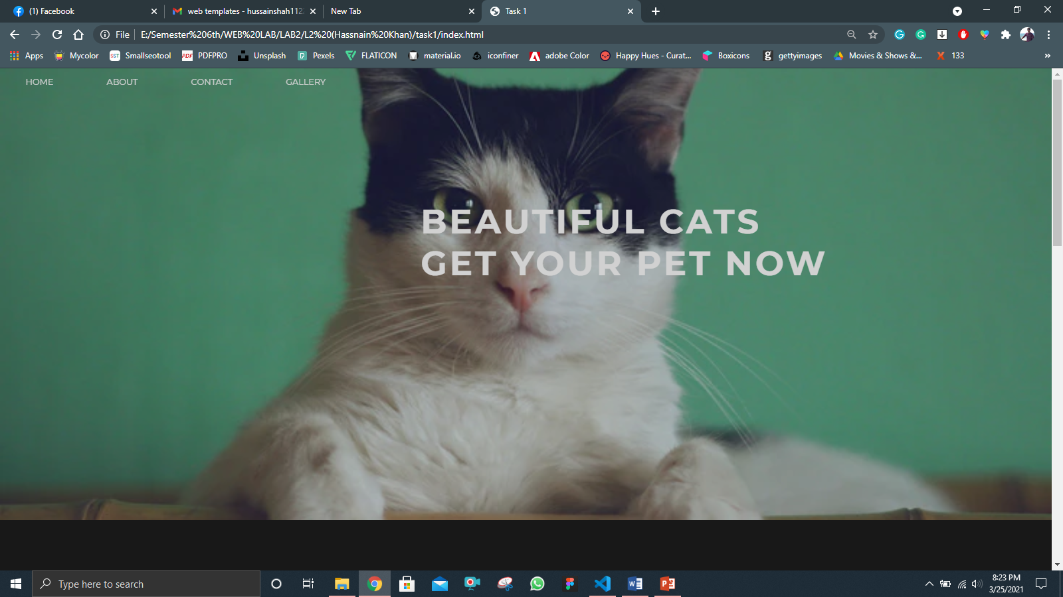

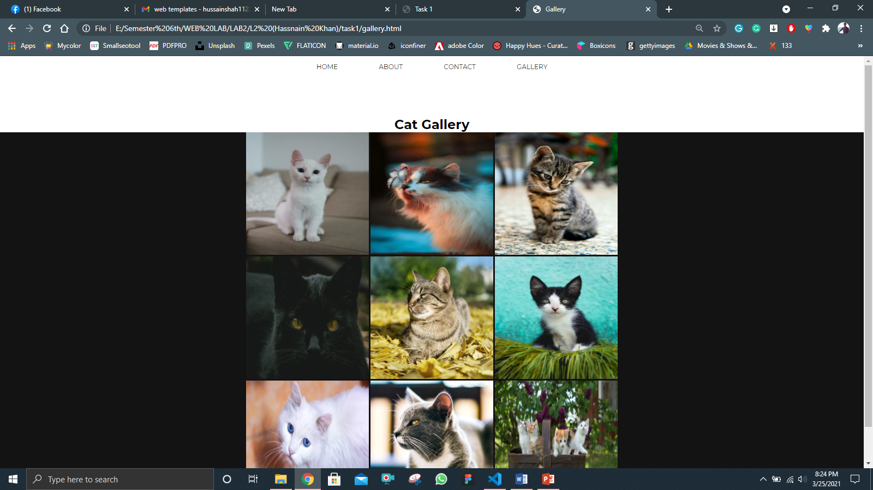

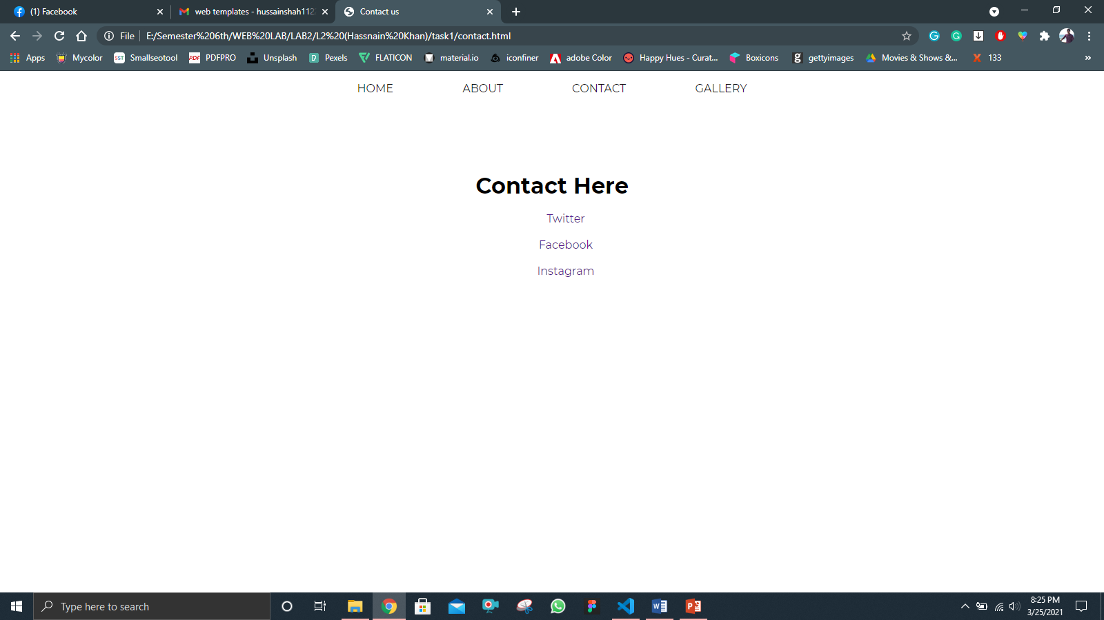

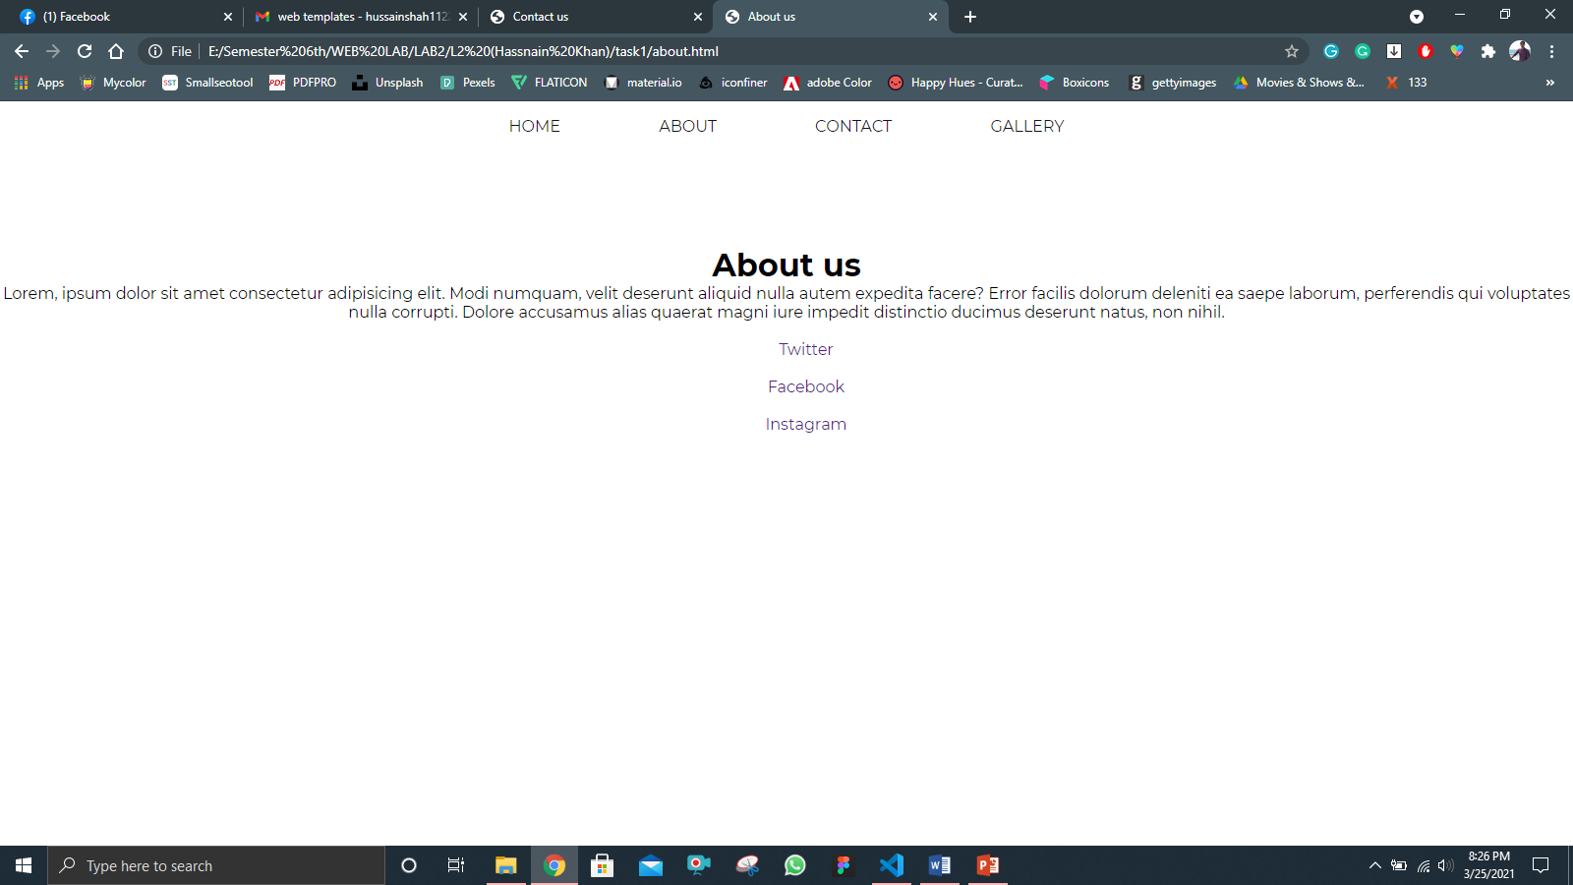

**Task 2:**

**Code:**

<!DOCTYPE html>

<html lang="en">

<head>

    <meta charset="UTF-8">

    <meta http-equiv="X-UA-Compatible" content="IE=edge">

    <meta name="viewport" content="width=device-width, initial-scale=1.0">

    <title>Task 2</title>

    <link rel="stylesheet" href="style.css">

</head>

<body>

        <h1>Welcome to this page</h1>

        <h2>Welcome to this page</h2>

        <h3>Welcome to this page</h3>

        <h4>Welcome to this page</h4>

        <h5>Welcome to this page</h5>

        <h6>Welcome to this page</h6>

        <p>

          Lorem ipsum dolor sit amet, consectetur adipisicing elit. Ratione

          molestias nihil et maxime nobis magnam id vero aut architecto natus?

        </p>

</body>

</html>

**Output:**

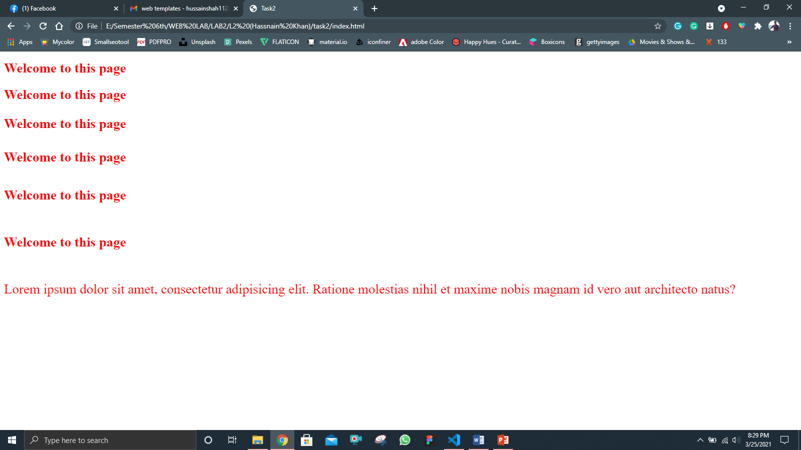

**Task 03:**

**Code:**

<!DOCTYPE html>

<html lang="en">

  <head>

    <meta charset="UTF-8" />

    <meta http-equiv="X-UA-Compatible" content="IE=edge" />

    <meta name="viewport" content="width=device-width, initial-scale=1.0" />

    <title>Task3</title>

    <link rel="stylesheet" href="style3.css" />

  </head>

  <body>

    <header></header>

    <main style="text-align: center">

      <h1>The image is fixed</h1>

      <h2>

        Lorem, ipsum dolor sit amet consectetur adipisicing elit. Soluta, alias?

      </h2>

      <p>

        Lorem, ipsum dolor sit amet consectetur adipisicing elit. Magnam, ad.

        Vitae repellendus voluptatum, illum vero dolorem ipsam deleniti eveniet

        cum sit iste excepturi veniam architecto cupiditate neque perferendis

        ab, reiciendis provident officiis minima, tenetur ut ipsum commodi ad.

        Commodi similique amet sequi, omnis accusamus facere!

      </p>

    </main>

  </body>

</html>

CSS

* {

    margin: 0;

    padding: 0;

    box-sizing: border-box;

  }

  body {

    font-size: 18px;

  }

  header {

    background-image: url("https://wallpapercave.com/wp/wp3717577.jpg");

    height: 90vh;

    margin-top: 2rem;

    background-repeat: no-repeat;

    background-size: cover;

    background-position: center;

    background-attachment: fixed;

  }

**Output:**

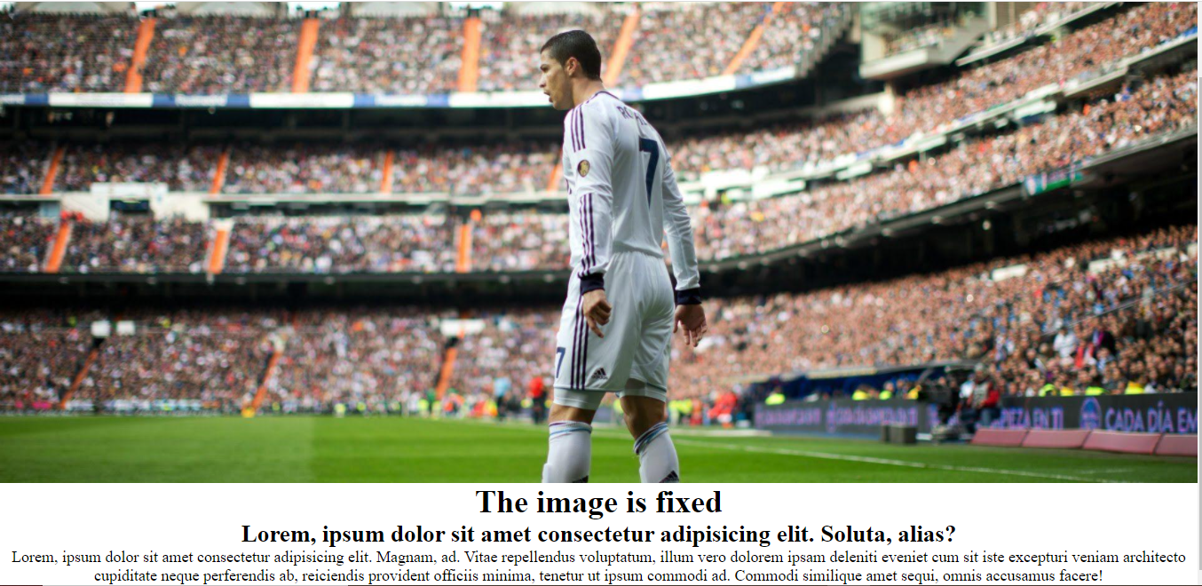

**Task 04:**

**Code:**

<!DOCTYPE html>

<html lang="en">

  <head>

    <meta charset="UTF-8" />

    <meta http-equiv="X-UA-Compatible" content="IE=edge" />

    <meta name="viewport" content="width=device-width, initial-scale=1.0" />

    <title>Document</title>

    <style>

      h1,

      h2 {

        border: 1px dashed black;

        padding: 0.5em;

        margin: 0.5em;

        display: block;

        width: 50%;

      }

    </style>

  </head>

  <body>

    <main>

      <h1>This is the first heading</h1>

      <h2>This is the second heading</h2>

    </main>

  </body>

</html>

**Output:**

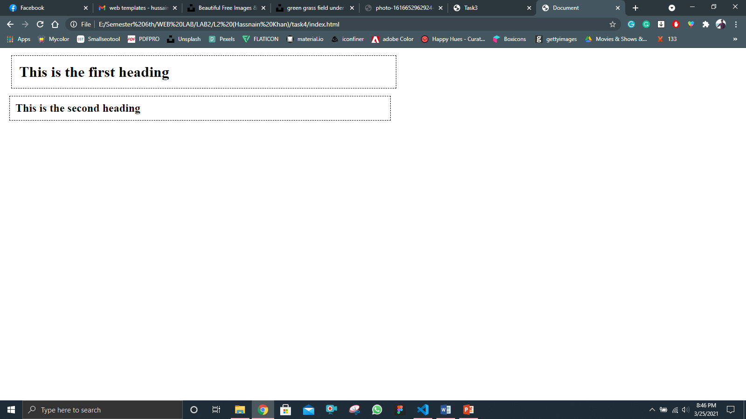

**Task 05:**

**Code:**

<!DOCTYPE html>

<html lang="en">

  <head>

    <meta charset="UTF-8" />

    <meta http-equiv="X-UA-Compatible" content="IE=edge" />

    <meta name="viewport" content="width=device-width, initial-scale=1.0" />

    <title>Task5</title>

    <style>

      h1 {

        color: blue;

      }

      li {

        list-style: none;

        font-size: 19px;

      }

      a {

        text-decoration: none;

        transition: all 0.2s;

      }

      a:hover {

        /* color: yellow; */

        background-color: yellow;

      }

    </style>

  </head>

  <body>

    <h1>Here is Humza's favorite Sites:</h1>

    <p>Click a name to visit this site.</p>

    <ul>

      <li><a href="#">Facebook</a></li>

      <li><a href="#">Twitter</a></li>

      <li><a href="#"> FourSquare</a></li>

      <li><a href="#">Google</a></li>

    </ul>

  </body>

</html>

**Output:**

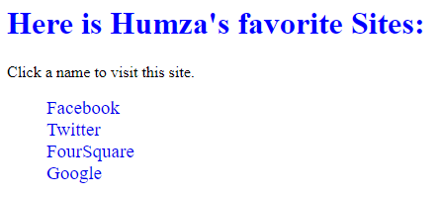

**Task 06:**

**Code:**

nav {

}

.nav-list {

  padding: 1rem 0;

  cursor: pointer;

}

.nav-item {

  display: inline;

  padding: 1rem 2rem;

  color: white;

  opacity: 1 !important;

  font-weight: 400;

  text-transform: uppercase;

  cursor: pointer;

  margin: 20px 1rem;

  transition: all 0.3s;

}

.nav-list a {

  text-decoration: none;

}

.nav-item:hover {

  background-color: white;

  color: rgb(27, 27, 27);

}

<nav>

            <ul class="nav-list">

                <a href="C:\Users\spring2018.BUKC\Desktop\L2\task1\index.html"><li class="nav-item">Home</li></a>

                <a href="C:\Users\spring2018.BUKC\Desktop\L2\task1\about.html"><li class="nav-item">About</li></a>

                <a href="C:\Users\spring2018.BUKC\Desktop\L2\task1\contact.html"><li class="nav-item">Contact</li></a>

                <a href="C:\Users\spring2018.BUKC\Desktop\L2\task1\gallery.html"><li class="nav-item">Gallery</li></a>

            </ul>

        </nav>

**Output:**

